Related Products: Sigma-5, SigmaWin+ 5.62 or later

Question? What is the basic technique for manually tuning a Sigma-5 system with high inertia?

Answer:

Sigma-5 High inertia tuning technique is best performed with the Advanced one-parameter tuning feature within SigmaWin+.

Example:

SGMAV-01 @ 50:1 inertia load (6 weighted discs) as rigid model

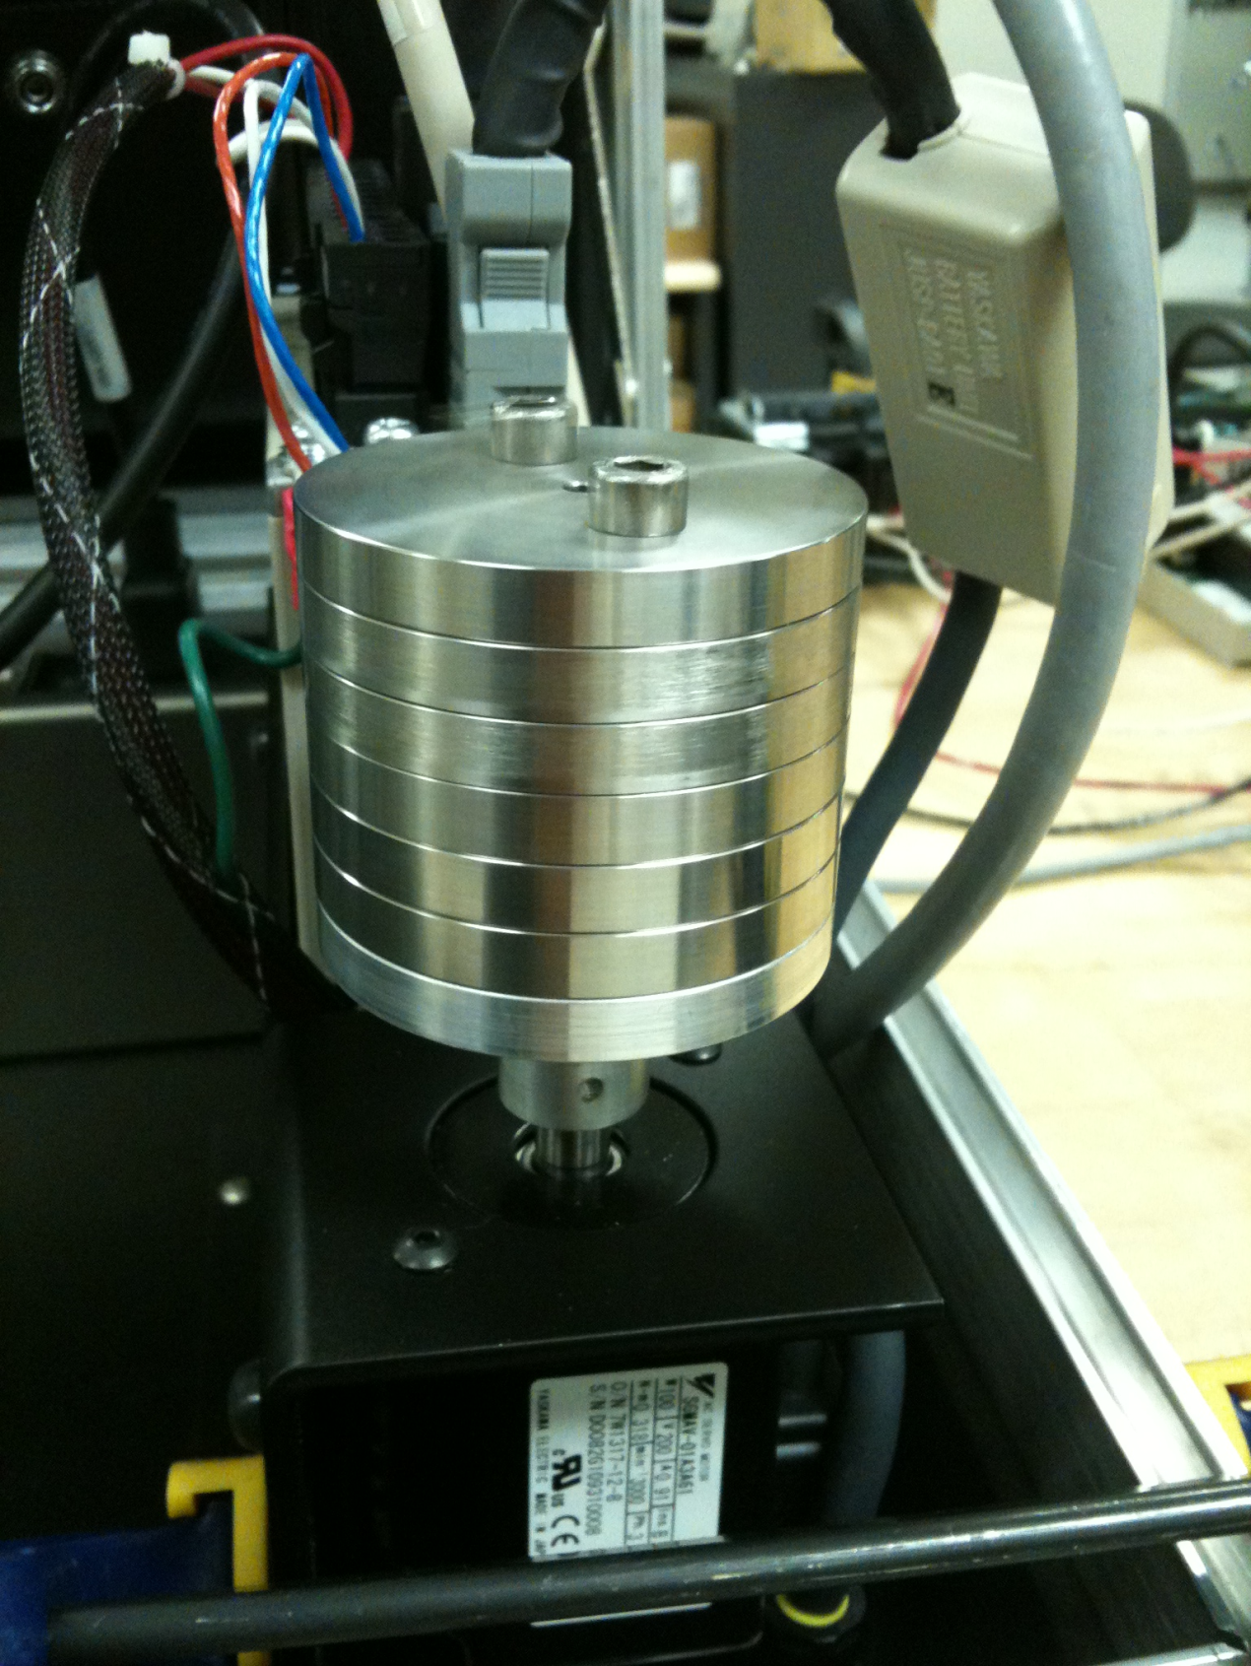

Tuning-less mode level 4 (default) mode performance results.

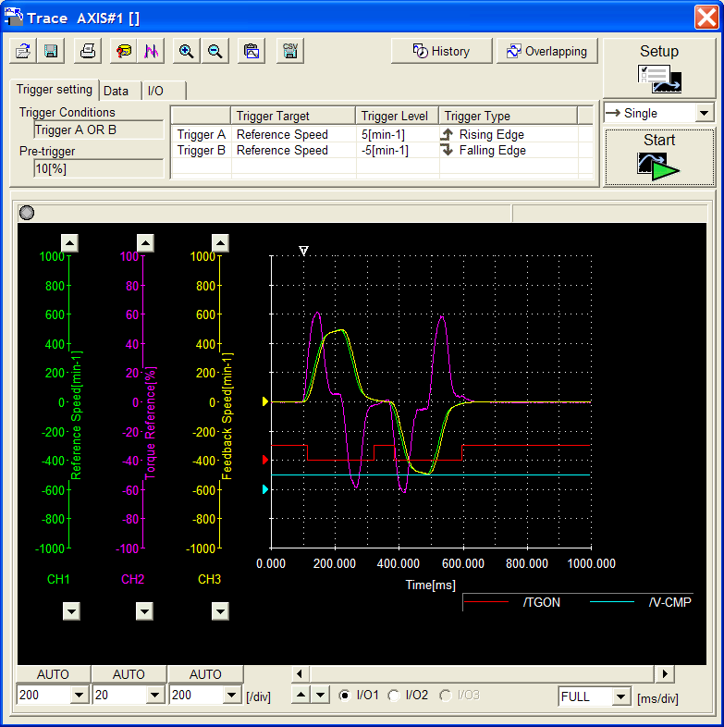

If performance is not adequate, attempt Sigma-Win+ auto-tuning. If Auto-tuning fails due to high inertia, Identify (or manually calculate) load inertia and enter into Pn103.

Select “Advanced adjustment. Then select manually adjust gain and vibration





Use Advanced One-parameter tuning…start with very low tuning levels FF and FB < 10 to start.

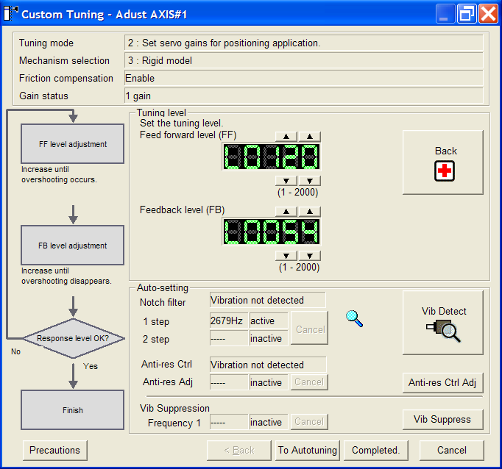

Adjust FF and FB incrementally till desired result. Use continuous trace to monitor Program Jog move and validate performance.

Results…

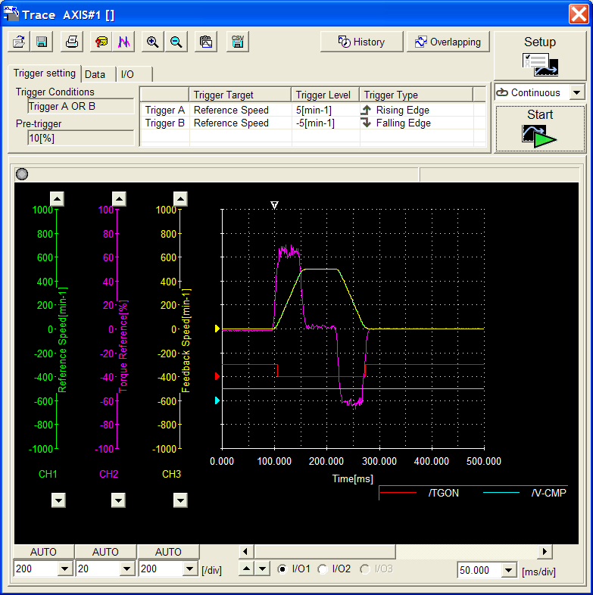

Set Notch…if high frequency noise is present. Use Mechanical analysis menu tool and set identified notch.

