The following charts indicate the memory allocation for the MPiec Series Controllers. This can be found in the MotionWorks IEC Configuration Help File, Section 4.
Physical Memory | MP2600iec | Sigma7-Siec | MP2300Siec | MP2310iec | MP3200iec | MP3300iec (400MHz) | MP3300iec (800MHz) | MP3300iec (1.2 GHz) | Notes
Size of FLASH | 8 MB | 8 MB | 8 MB | 8 MB | 40 MB | 48 MB | 48 MB | 48 MB
Size of static RAM memory (battery backed up) | 0.5 MB | 0.0 MB | 0.5 MB | 2 MB | 8 MB | 4 MB | 8MB | 8MB | Sigma7-Siec does not support battery backed memory
Size of dynamic RAM memory (cleared at power up) | 32 MB | 32 MB | 32 MB | 32 MB | 128 MB | 256 MB | 256 MB | 256 MB
FLASH Allocation:
Firmware and system files. | 4.5 MB | 4.5 MB | 4.5 MB | 4.5 MB | 8 MB * | 8 MB x2 ** | 8 MB x2 ** | 8 MB x2 ** | See notes on MP3200isec and MP3300iec below.
Flash file system for user files. | 3.5 MB  (1.4 MB) | 3.5 MB  (1.4 MB) | 3.5 MB | 3.5 MB | 32 MB  (10MB) | 32 MB  (10MB) | 32 MB  (10MB) | 32 MB  (10MB) | () = maximum bootproject size. Other files can include source code and user data.
Static RAM Allocation: (Battery backed memory)
System/Reserved | 34 KB | Not Supported | 34 KB | 34 KB | 1664 KB | 640 KB | 640 KB | 640 KB
Modbus | 34 KB |  | 34 KB | 34 KB | 64 KB | 64 KB | 64 KB | 64 KB | When MPiec is configured as a Server, the Modbus inputs can be retained
Axis Data | 56 KB |  | 60 KB | 60 KB | 64 KB | 64 KB | 64 KB | 64 KB | Absolute Encoder Offsets
Alarm History | 32 KB |  | 32 KB | 32 KB | 256 KB | 256 KB | 256 KB | 256 KB | As reported in web server
Retained Data | 352 KB |  | 352 KB | 951 KB | 6 MB | 3 MB | 7 MB | 7 MB | Global variables with 'Retain' checkbox checked
NOTE: The effective Retained Data memory area is divided by two to support the 'Download Changes' feature. (i.e. Up to 176 KB can be allocated on an MP2300Siec)
Dynamic RAM Allocation:
System | 13 MB | 13 MB | 13 MB | 13 MB | 32 MB | 32 MB | 32 MB | 32 MB | Firmware
Ram file system | 4 MB | 4 MB | 4 MB | 4 MB | 24 MB | 24 MB | 24 MB | 24 MB | Ram disk file system
IEC 61131 Application | 2.3 MB | 2.3 MB | 3.5 MB | 3.5 MB | 29 MB | 57 MB | 57 MB | 57 MB | Code & Data
Cam Tables | 7.5 MB | 7.5 MB | 7.5 MB | 7.5 MB | 20 MB | 20 MB | 20 MB | 20 MB | Running cam tables transferred to the motion engine using Y_CamFileSelect or Y_CamStructSelect

Figure 1 Controller Memory from the MotionWorks IEC Hardware Configuration Manual, Section 4
System Flash on the MP3200iec and MP3300iec
* Separate flash device from the user flash.
** The MP3300 has 2x8MB to allow a new firmware image to be programmed while keeping the current image as a backup in case of power loss during programming.
User Flash on the MP2600iec and Sigma-7Siec
For MP2600iec and Sigma-7Siec the controller has 3.5MB available in the flash file system for user file storage. The MotionWorksIEC project size is limited to 1.4MB due to the need for double memory when the program is swapped during runtime. About 0.7MB is available for other user files such as Config, Cam/Data files, and other files which are not included as part of the MotionWorksIEC "user project".

Reallocating Non-Retained Memory on the MP2300Siec and MP2310iec
For the MP2300Siec and MP2310iec the amount of memory allocated to the IEC application program for non-retained variables is set at 1.5 MB and the memory allocation for Cam Storage/Data is set to 3.75MB, half the amount shown in the table. It is possible to increase the non-retained variable space is available by clicking the ‘Change Default Area User Settings’ button from the MotionWorks IEC Hardware Configuration Toolbar and choosing 3.2 MB. Please note, while this amount of memory can be increased, the memory for Cam Storage/Data will decrease to 2.25 MB.
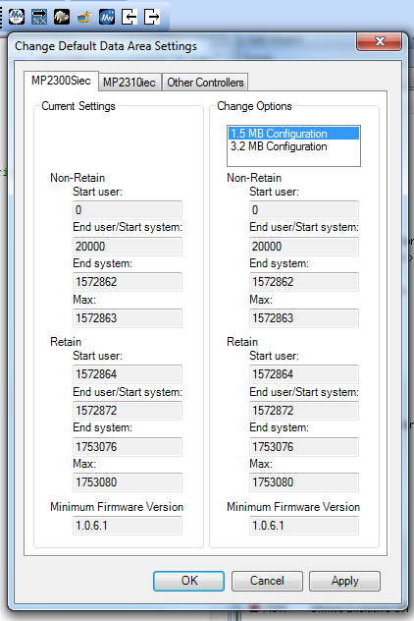
Figure 2 How to Increase Non-Retained Memory on the MP2300Siec and MP2310iec

