Battery Life
The serial encoder used in the Sigma-5 or Sigma-7 servo motor typically draws about 20 μA of current when the power to the amplifier is turned off. In this condition, the maximum life of the standard encoder data backup battery (P/N JZSP-BA01) is:

1000x10^-3 A-hour / 20x10^-6 A = 50,000 hours (5.7 years)

When power is applied to the amplifier, the current draw from the battery is typically 3 μA.
Assuming that the amplifier is on for 12 hours and off for 12 hours each day, the maximum life of the battery in this condition is:

Power On: 3x10^-6 A x 12 hour = 0.036 mAh

Power Off: 20x10^-6 A x12 hour = 0.24 mAh

0.036 mAh + 0.24 mAh = 0.276 mAh per day

1000mAh / 0.276mAh per day = 3623.2 days (9.9 years)

Battery Alarm or Warning
The amplifier can be configured to produce an alarm (A.830) or warning (A.930) in response to low battery condition. A low battery condition is when the voltage drops to approximately 2.7V or less.

The default configuration is for the amplifier to produce an alarm (A.830). However, the detection for this Alarm only occurs within the first few seconds of control power application.

The alternate configuration (producing A.930) is configured by setting PN008.0 = 1. In this mode the amplifier will generate the warning after approximately 5 seconds after control power is applied and alarm status is normal.

Please see the image below for details on the difference between alarm and warning configuration.

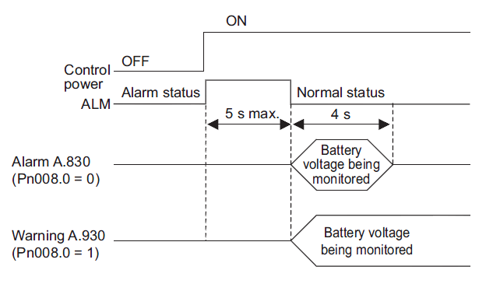

Battery Replacement
- Turn ON the control power supply of the SERVOPACK only.
- Remove the old battery and mount the new battery.
- After replacing the battery, turn OFF the control power supply to clear the absolute encoder battery error alarm (A.830).
- Turn ON the control power supply again.
- Check that the alarm display has been cleared and that the SERVOPACK operates normally.

*Note: Receiving an A.830 alarm does not mean the back-up data in the encoder has been comprised, just the battery level is low and should be replaced soon. If the battery isn’t replaced in a timely manner, an A.810 Encoder Backup Error alarm will occur. If an A.810 alarm occurs, then the back-up data has been lost. Clearing an A.810 alarm is beyond the scope of this FAQ.

